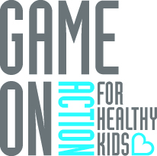
School Health Action Plan

Congratulations on completing the School Health Index! It’s now time to develop your school-level action plan. Using the report your school received after submitting the School Health Index, identify 3-5 priorities based on your school’s Opportunities for Growth (log into your school portal account to view the report). For each priority, determine specific activities that are needed to help you improve your score in that area. Be sure to include a start and end date, the name of the person(s) responsible, required resources, relevant Game On activities that will help you implement the activity, and measures of success that will inform you of whether or not you have accomplished the activity successfully. Add rows as needed to address all priorities for this year. Good luck! Contact us as needed for one-on-one support.
Activity | Start Date |  | End Date |  | Person(s) Responsible |  | Resources Required |  | Volunteers Needed? |  | Game On Activities |  | Measures of Success
Priority #1:
Priority #2:
Priority #3:
Priority #4:
Priority #5:

